**$500 Healthy Diet (For Obesity)**

(Including Breakfast, Lunch and Dinner)

* Oats 1.5Kg - Enough for 30 meals
  + Brought from Best Mart 360
  + Approximately $18 per 1kg
  + Price: $27
* Chicken Chops (Large) 15 Pieces – Enough for 30 meals
  + Brought from market
  + Approximately ~ $11 per Piece
  + Price: $165

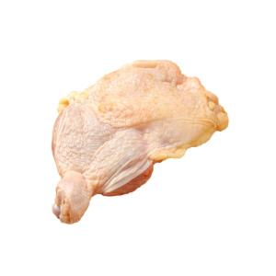

* Marie Biscuit 2 Packets - Enough for 60 meals
  + Brought from welcome supermarket
  + Approximate $26 for 2 packets
  + Price: $36

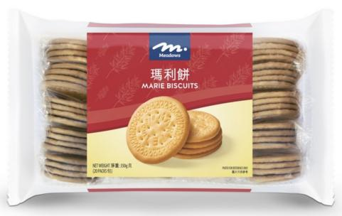

* Vegetables 6kg - Enough for 30 meals
  + Brought from market
  + Approximate $8 per kg
  + Price $48

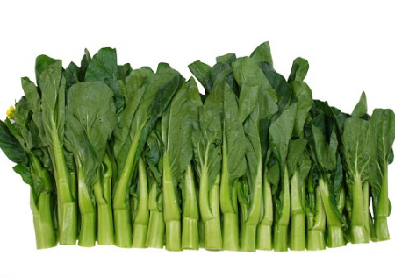

* Best Mart 360 Premium Thai Fragrant Rice 5kg – Enough for 30 meals
  + Brought from Best Mart 360
  + Approximately ~ $49 per packet
  + Price: $55



* Apple 30 ones (small) - Enough for 60 meals
  + Brought from market
  + Approximate $20 for 14 ~ $1.4 for one apple
  + Price $43
* (**Optional**) Devondale Milk 7 large boxes 1 Liter - Enough for 30 meals
  + Brought from ParknShop supermarket
  + Price $118.3

**Total Price: Approximate $492.3 (All in terms of Hong Kong Dollars)**

*Updated: 5th March 2025 price subject to change*

**Ingredients And Menus (Total 90 Meals)**

3 Meals Per Day (Breakfast, Luch and Dinner) for 90 days

**These ingredients are based on portions. In case you don’t how to accurately divide it into portion. You can use a balance to weight the net weight of the ingredients and then divide it into portions base on the net weight.**

* Breakfast meal *– (30 meals) (Served for Breakfast)*

1. Fish or Meat (Fresh) 1 onces (30 grams).
2. Bread 2 slices or Oat meal (8 spoonfull of dried Oats, equilvanent to 40 grams).

* Breakfast 10:00AM *– (30 meals) (Served for Breakfast 10:00AM)*

1. Marie Biscuit (3 pieces ~ 15grams) or Bread half slice.

* Luch meal*– (30 meals) (Served for Lunch)*

1. Broth Soup (Optional).
2. Fish or Meat 3 onces (90 grams)
3. Vegetables not less than 2/3 (two third fractional) Bowl.
4. Rice 1 2/5 (one and two fifth fractional) Bowl.

* Afternoon Tea *– (30 meals) (Served for Afternoon Tea)*

1. Marie Biscuit (3 pieces) or Bread half slice.
2. Fruits (Eg. 1 orange or 1 apple).

* Dinner *– (30 meals) (Served for Dinner)*

1. Broth Soup (Optional).
2. Fish or Meat 3 onces (90 grams)
3. Vegetables not less than 2/3 (two third fractional) Bowl.
4. Rice 1 2/5 (one and two fifth fractional) Bowl.

* Before Bed *– (30 meals) (Served for Before Bed)*

1. Skimmed Milk 1 Cup.
2. Fruits (Eg. 1 orange or 1 apple).

* Everyday
  + Only allow 3 tea spoon of oil.
  + One Bowl equals 300 milligrams (300 grams).